HOMEWORK
BACKGROUND INFO
Calkoo introduced a simple online VAT calculator for calculating tax on their website:
http://www.calkoo.com/?lang=3&page=8

USER STORY
As a traveller, I want to calculate the various purchase/tax amounts to verify that my shop receipt is correct, and the merchant correctly charged the VAT for my recently bought items.

ACCEPTANCE CRITERIA
• User must select a country which applies VAT scheme
• User must be able to choose a valid VAT rate for the selected country
• One of the following amounts are supported as an input:
o Net
o Gross
o VAT
• Amounts can be entered with maximum 2 decimal digit precision
• Given all mandatory fields (country, vat rate, one of the amounts) are provided, the website will calculate and show the other 2 amounts which were not provided originally as an input value
• The API provides an error with meaningful error message, in case of:
o negative input
o amount >999.999.999

TECHNICAL REQUIREMENTS
• Please document test cases (manual) that come to your mind.
• In case you encounter bugs - which one and how would you report them (provide example)
• In case there are open questions regarding requirements/acceptance criteria:
o Document the questions you would like to ask/clarify with End users/business/product owner based on the given information.
• Please identify at least two test cases for automation:
o explain why you would choose specifically those
o automate them using Cypress, Robot or Selenium (if having experience)

TEST CASES:
Test Case 1: Verify that the user can select a country which applies to a VAT scheme.
Open the Calkoo VAT calculator website. (By default, the country United Kingdom should already be selected).
Select a country and VAT rate.
Verify that the selected country is displayed correctly.
Verify that the VAT rate for the selected country is displayed. (Some cases may show more than one rate).

Test Case 2: Verify that the user can choose a valid VAT rate for the selected country.
Open the Calkoo VAT calculator website. (By default, the country United Kingdom should already be selected).
Select a country and VAT rate.
Verify that the selected VAT rate is displayed correctly in the calculator.
Verify that the user can enter the Net amount and calculate the Gross and VAT amounts.

Test Case 3: Verify that one of the following amounts are supported as an input: Net.
Open the Calkoo VAT calculator website. (By default, the country United Kingdom should already be selected).
Select a country and VAT rate.
Enter a positive value valid amount in the "Price without VAT" field.
Verify that the calculated Gross and VAT amounts are displayed correctly.

Test Case 4: Verify that one of the following amounts are supported as an input: Gross.
Open the Calkoo VAT calculator website. (By default, the country United Kingdom should already be selected).
Select a country and VAT rate.
Select the box “Price incl. VAT” and enter a positive value valid amount.
Verify that the calculated Net and VAT amounts are displayed correctly.

Test Case 5: Verify that one of the following amounts are supported as an input: VAT.
Open the Calkoo VAT calculator website. (By default, the country United Kingdom should already be selected).
Select a country and VAT rate.
Select the box “Value-Added Tax” and enter a positive value valid amount.
Verify that the calculated Net and Gross amounts are displayed correctly.

Test Case 6: Verify that Price without VAT amounts can be entered with maximum 2 decimal digit precision.
Open the Calkoo VAT calculator website. (By default, the country United Kingdom should already be selected).
Select a country and VAT rate.
Enter an amount in the "Price without VAT" field with more than 2 decimal digits.
Verify that the amount is rounded to 2 decimal digits, the entered net amount is accepted and displayed correctly, and the calculated gross and VAT amounts are correct based on the entered net amount and VAT rate.
Test Case 7: Verify that Price incl. VAT amounts can be entered with maximum 2 decimal digit precision.
Open the Calkoo VAT calculator website. (By default, the country United Kingdom should already be selected).
Select a country and VAT rate.
Enter a valid Price incl. VAT (positive value) with up to 2 decimal digit precision.
Verify that the entered Price incl. VAT amount is accepted and displayed correctly.
Verify that the calculated net and VAT amounts are correct based on the entered Price incl. VAT amount and VAT rate.

Test Case 8: Verify that Value-Added Tax amounts can be entered with maximum 2 decimal digit precision.
Open the Calkoo VAT calculator website. (By default, the country United Kingdom should already be selected).
Select a country and VAT rate.
Enter a valid Value-Added Tax amount (positive value) with up to 2 decimal digit precision.
Verify that the entered Value-Added Tax amount is accepted and displayed correctly.
Verify that the calculated net and gross amounts are correct based on the entered Value-Added Tax amount and VAT rate.

Test Case 9: Verify that given all mandatory fields (country, vat rate, one of the amounts) are provided, the website will calculate and show the other 2 amounts which were not provided originally as an input value.
Open the Calkoo VAT calculator website. (By default, the country United Kingdom should already be selected).
Click on the "Select Country" dropdown menu.
Select a valid VAT rate for the selected country.
Enter a valid amount in the "Price without VAT" field.
Verify that the Gross amount is calculated and displayed.
Clear the "Price without VAT" field.
Verify that the Gross amount is displayed in the "Price without VAT" field.
Clear the "Gross" field.
Verify that the VAT amount is displayed in the "Gross" field.

Test Case 10: Verify that the API provides an error with meaningful error message, in case of negative input and amount >999.999.999
Open the Calkoo VAT calculator website. (By default, the country United Kingdom should already be selected).
Click on the "Select Country" dropdown menu.
Select a valid VAT rate for the selected country.
Enter a negative amount in the "Price without VAT" field.
Verify that an error message is displayed (Negative values are invalid for a pie chart).
Clear the "Net" field.
Enter an amount greater than 999.999.999 in the "Price without VAT" field.
Verify that an error message is displayed.

Test Case 10.1: Verify that the API provides an error with meaningful error message, in case of negative input.
Open the Calkoo VAT calculator website. (By default, the country United Kingdom should already be selected).
Select a country and VAT rate.
Enter a negative value for any of the amounts (net, gross, or VAT amount).
Verify that an error message (Negative values are invalid for a pie chart) is displayed indicating that negative values are not allowed.

Test Case 10.2: Verify that the API provides an error with meaningful error message, in case of amount >999.999.999
Open the Calkoo VAT calculator website. (By default, the country United Kingdom should already be selected).
Select a country and VAT rate.
Enter an amount greater than 999,999,999 for any of the amounts (as the net, gross, or VAT amount).
Verify that an error message is displayed indicating that the amount is invalid or exceeds the maximum allowed limit. (When an amount greater than 999,999,999)

BUG REPORTING
Title: Incorrect calculation of Gross amount

Description: After an analysis of the vat-calculator app, I identified a possible failure in the calculation of the net value (Net) when using a value with a decimal precision greater than two digits.

Steps to Reproduce:
Go to https://www.calkoo.com/en/vat-calculator.
Select a country that applies to the VAT scheme. (Austria as an example)
Enter a value in the "Net Amount" field with more than two decimal places, for example 10,123.
Choose a valid VAT rate for the selected country. (10%)
Note the calculated value for the "Net Amount" field after the calculation.

Expected Result: The Net Amount must be calculated and displayed correctly, rounded to two decimal places. In the example mentioned, the expected gross value would be 11.133.

Actual Result: Net Amount calculation does not correctly round values ​​with decimal precision greater than two digits. In the example mentioned, the calculated value might be displayed as 11.14 instead of 11.133.

Attached screenshots: Attach screenshots showing the incorrect calculation.

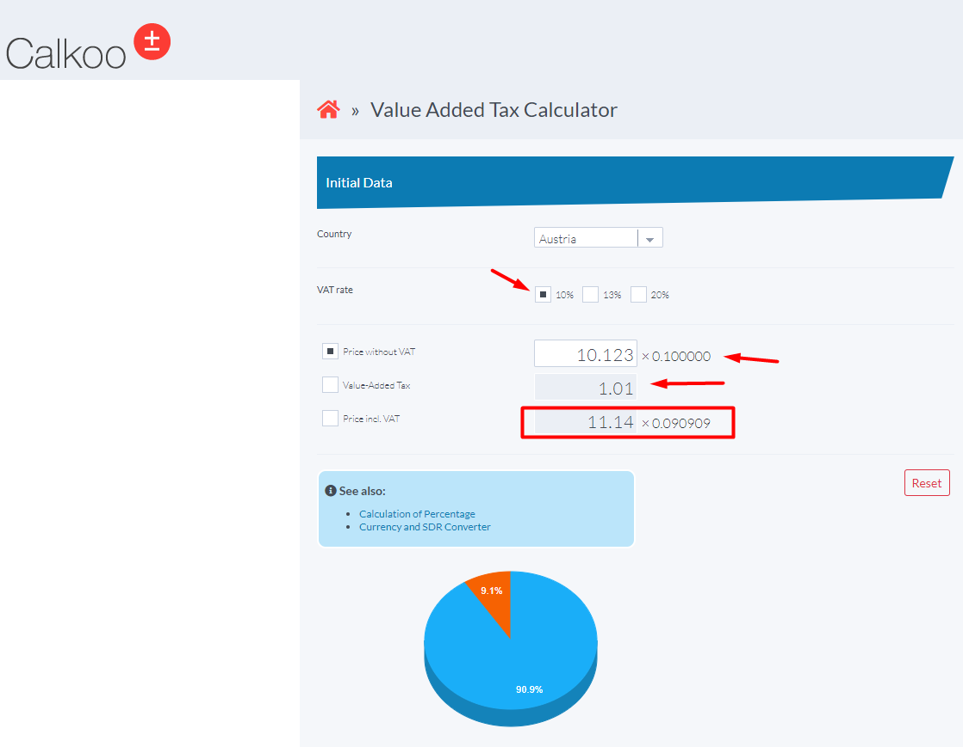

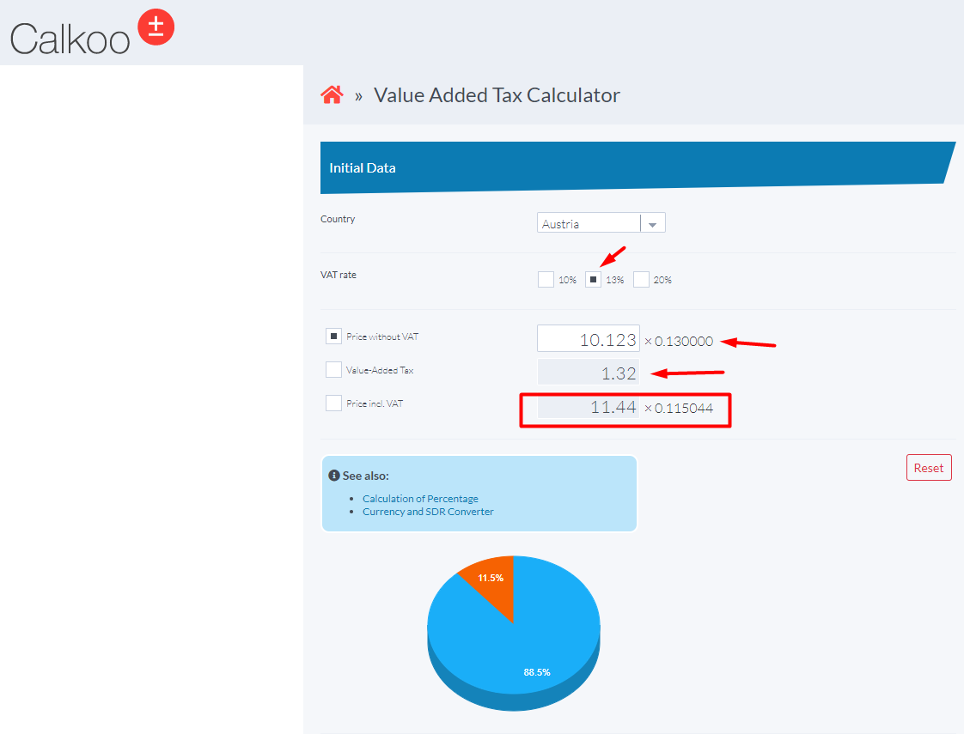

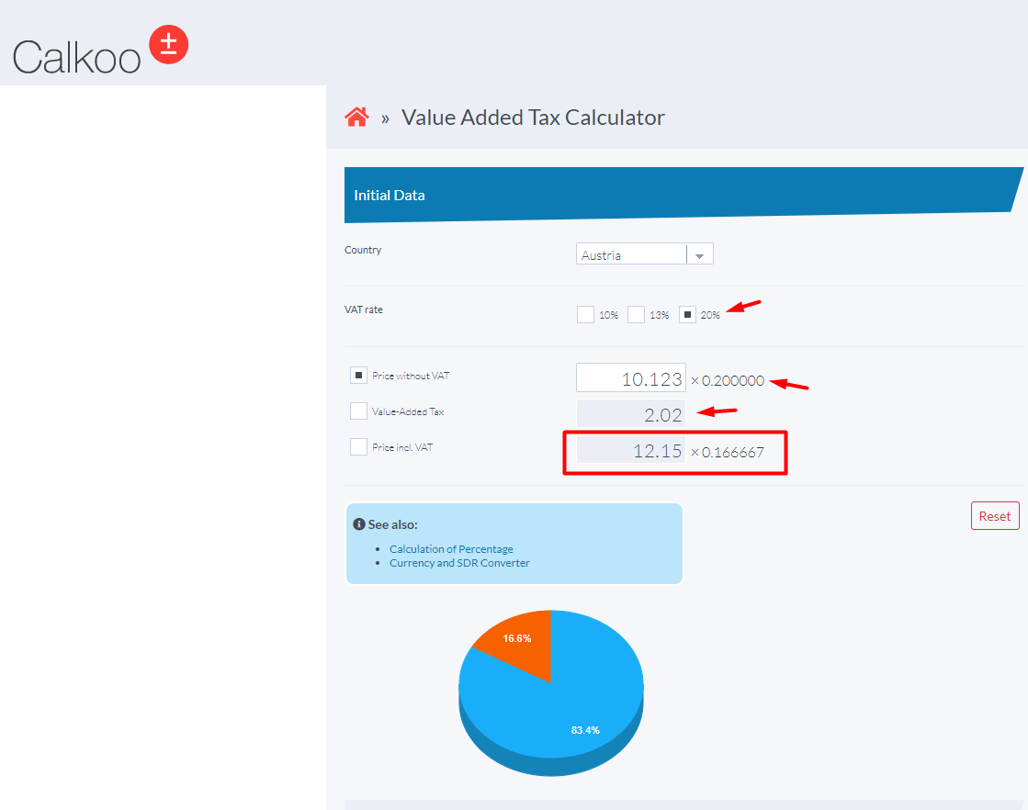

Recommendation:
I recommend that the team responsible for developing the site review the rounding logic applied to the Net Amount calculation to ensure that it displays correctly to two decimal places.

QUESTIONS FOR CLARIFICATION:
Are there any specific countries or VAT rates that should be supported?
Are there any specific validation rules for the input amounts, such as minimum values or allowed formats?
Should the application support multiple calculations on the same page or is it a single calculation at a time?
Is there any specific design or layout requirement for the calculator interface?
Should the application provide any additional functionality or information related to VAT calculation?
Are there any performance or security requirements that need to be considered for the application?

TEST AUTOMATION:
- Explain why you would choose specifically those.
The two tests mentioned were automated to ensure the correct functionality of the VAT (Value Added Tax) calculator on the Calkoo website. Let's understand the justification for each of them:

Test Case 1: Verify that the user can select a country which applies to a VAT scheme.
In this test, the aim is to ensure that the user can correctly select a country in which the VAT scheme is applicable. This is important because each country can have different VAT schemes with varying rates. By automating this test, we can verify that the country selection is working correctly and that the selected country is displayed correctly in the UI.

Test Case 2: Verify that the user can choose a valid VAT rate for the selected country.
This test is intended to ensure that the user can correctly select a valid VAT rate for the chosen country. Each country may have different applicable VAT rates, and it is important that the user can select a valid rate according to the selected country. By automating this test, we can verify that the VAT rate selection is working correctly and that the selected rate is displayed correctly in the calculator. In addition, we verify that the user can correctly enter the Net amount and correctly calculate the Gross amount and VAT.
Automating these tests has significant benefits, such as:
Ensuring that the country and VAT rate selection flow works correctly, avoiding manual errors during repetitive testing.
Identify and correct potential country selection or VAT rate issues more efficiently.
Facilitate the regular execution of these tests, allowing incorporation into continuous integration (CI/CD) pipelines to ensure continuous application quality.
Automating these tests helps increase app reliability, reduce human error, and ensure the VAT calculator is working correctly for the different countries and applicable VAT rates.

- Automate them using Cypress, Robot or Selenium (if having experience)
There are two test cases that were automated using Java, Selenium, Cucumber, Junit and Page Object Model for this project automation. Please have a look on this link below:
https://github.com/rcardosopereira/Calkoo
to see more details about the Calkoo project automation.

Thank you,
Rafael C. Pereira

